**ASSIGNMENT – 3**

**In class programming:**

1. Follow the instruction below and then report how the performance changed.(apply all at once)

• Convolutional input layer, 32 feature maps with a size of 3×3 and a rectifier activation function.

• Dropout layer at 20%.

• Convolutional layer, 32 feature maps with a size of 3×3 and a rectifier activation function.

• Max Pool layer with size 2×2.

• Convolutional layer, 64 feature maps with a size of 3×3 and a rectifier activation function.

• Dropout layer at 20%.

• Convolutional layer, 64 feature maps with a size of 3×3 and a rectifier activation function.

• Max Pool layer with size 2×2.

• Convolutional layer, 128 feature maps with a size of 3×3 and a rectifier activation function.

• Dropout layer at 20%.

• Convolutional layer,128 feature maps with a size of 3×3 and a rectifier activation function.

• Max Pool layer with size 2×2.

• Flatten layer.

• Dropout layer at 20%.

• Fully connected layer with 1024 units and a rectifier activation function.

• Dropout layer at 20%.

• Fully connected layer with 512 units and a rectifier activation function.

• Dropout layer at 20%.

• Fully connected output layer with 10 units and a Softmax activation function

Did the performance change?

2. Predict the first 4 images of the test data using the above model. Then, compare with the actual label for those 4

images to check whether or not the model has predicted correctly.

3. Visualize Loss and Accuracy using the history objectCode 1:

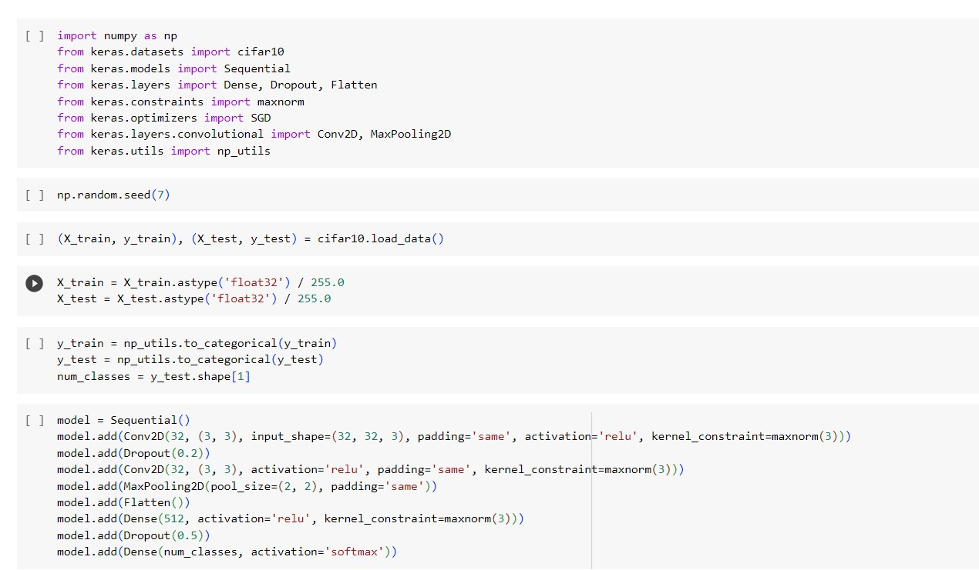

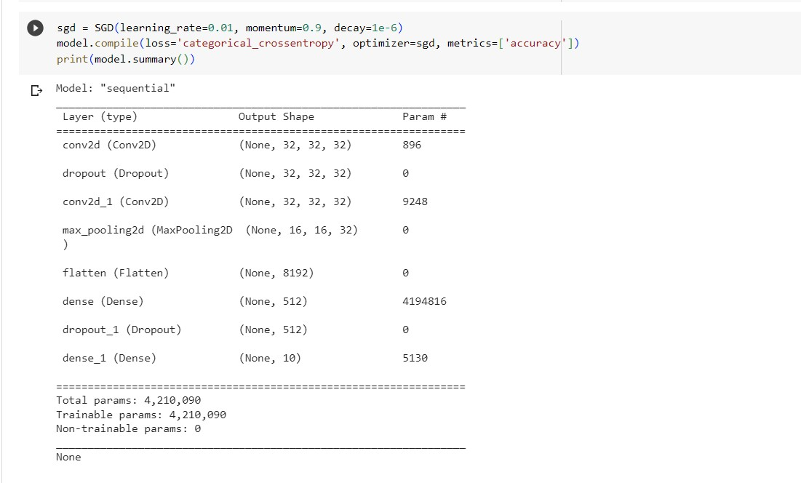

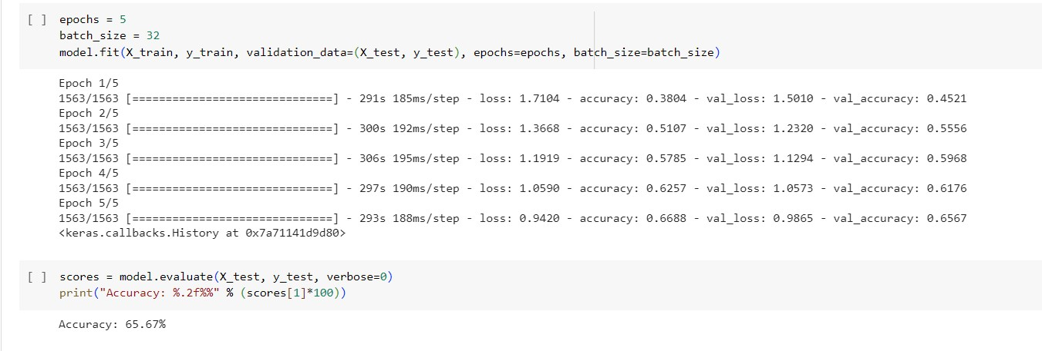

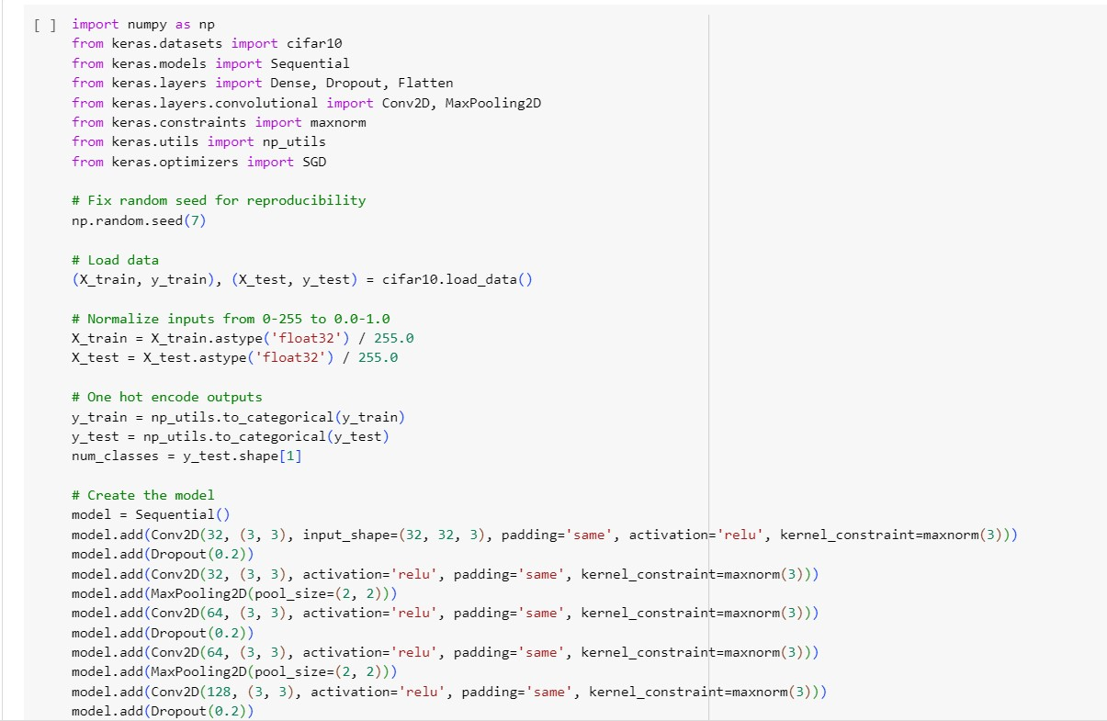

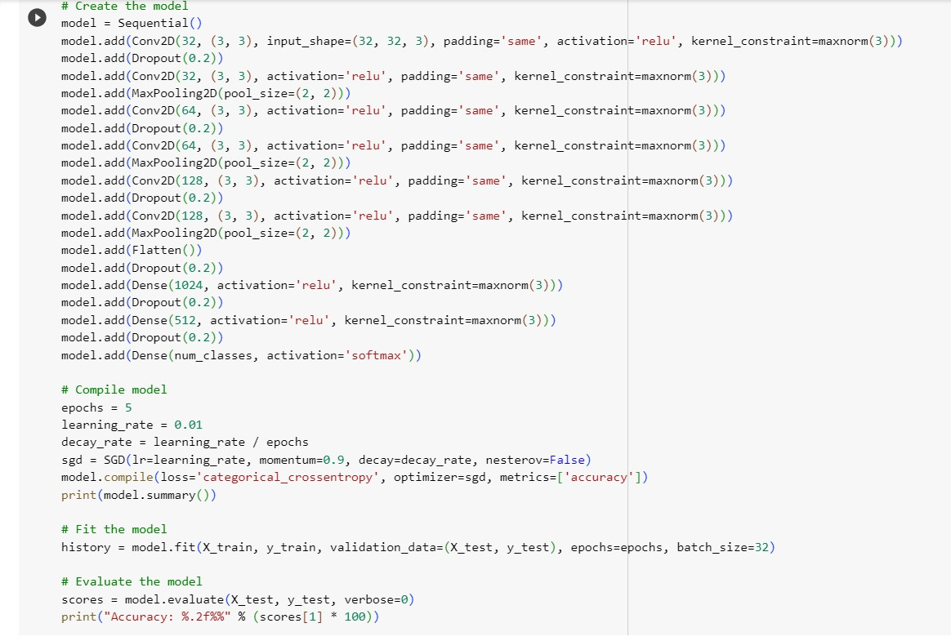

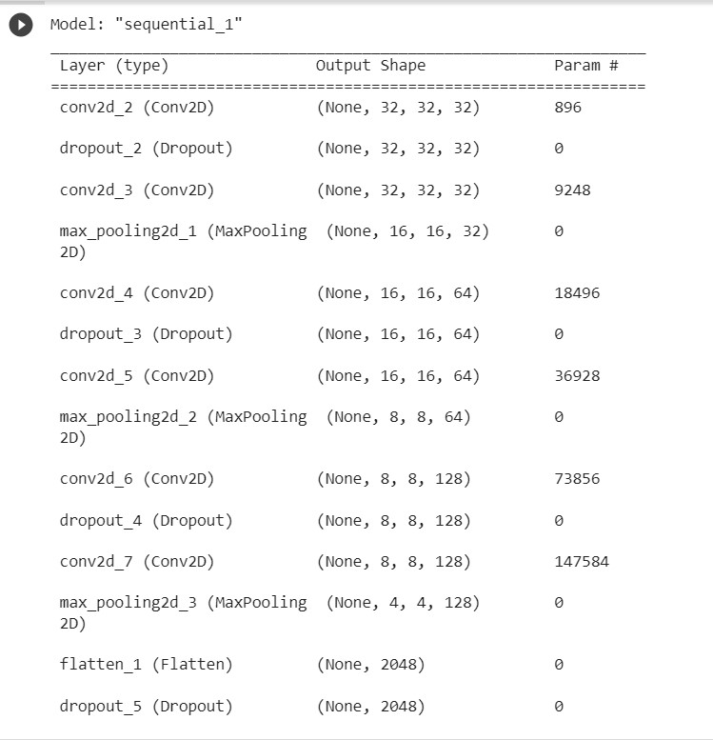

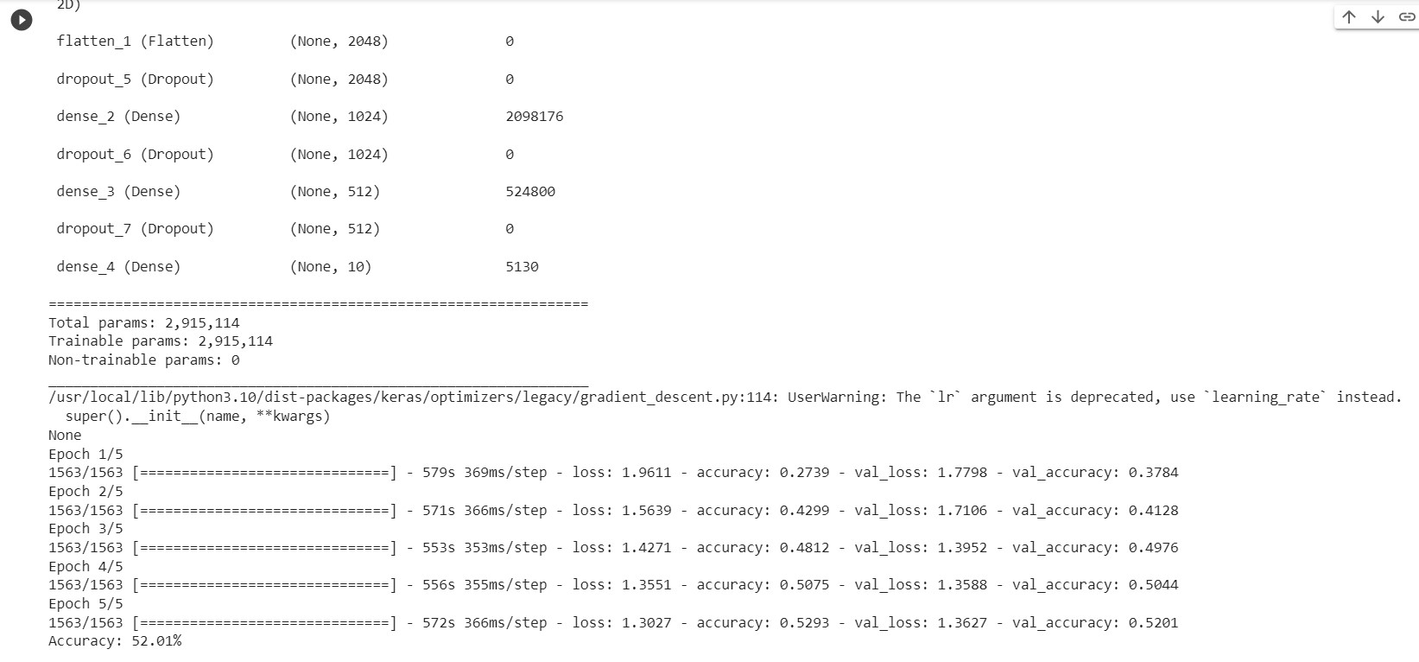

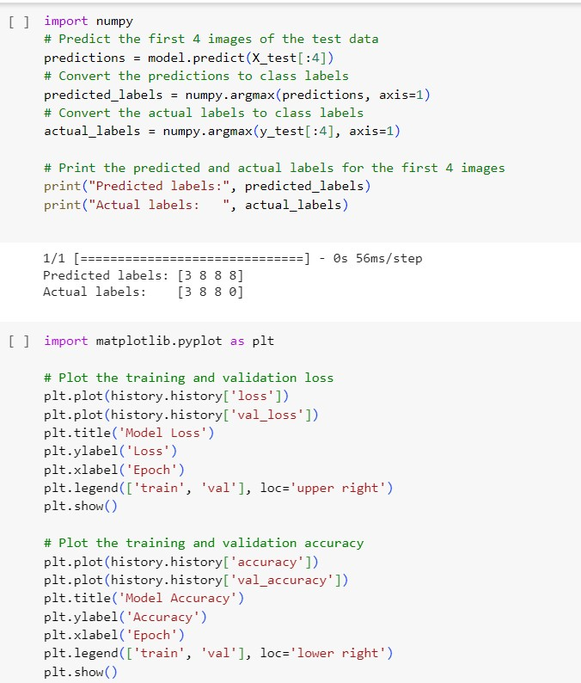

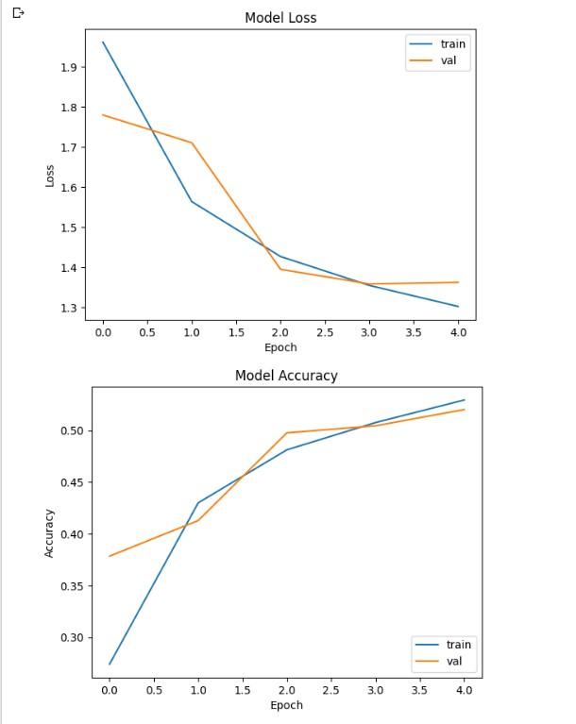

Github link : https://github.com/TriveniBala/NEURAL-Networks-Assignment-3-